
Catholic Junior College
JC2 Preliminary Examinations
Higher 2

GEOGRAPHY 9173/01

29 August 2025

3 hours

READ THESE INSTRUCTIONS FIRST

An Answer Booklet will be provided with this question paper. You should follow the instructions on the front cover of the answer booklet. If you need additional answer paper ask the invigilator for a continuation booklet.

Write your Centre number, index number and name on the work you hand in.

Write in dark blue or black pen on both sides of the paper.
You may use an HB pencil for any diagrams or graphs.

Do not use staples, paper clips, glue or correction fluid.

DO NOT WRITE ON ANY BARCODES.

Section A
Answer both questions.

Section B
Answer two questions, one from each cluster.

The number of marks is given in brackets [ ] at the end of each question or part question.

This document consists of 4 printed pages.
Section A

Answer both questions

Cluster 1 Development, Economy and Environment

1 | Resource 1 shows a map of BYD Electric Vehicle (EV) production plants around the world and their annual production capacity (thousands of units). Resource 2 shows the EV sales by continent. Resource 3 shows the major Chinese EV and EV battery manufacturing investments in Europe. EV batteries are crucial components in EVs. Resource 4 shows miners at a cobalt cleaning site in the Democratic Republic of the Congo. Cobalt is a crucial component in EV batteries.
 | (a) | Explain the influence of labour characteristics on TNC’s locational decisions.  Award 1m for each explanation. Award a maximum of 1 additional mark for further development of each explanation, where applicable.  - Skilled labour tends to attract investment of higher-value production parts of the TNC, such as that of research and development or high-end manufacturing. [1]  - This is because of the need to undertake very skilled work in these areas, including managerial and precision work. [+1]  - Low waged labour tends to attract low-end production, or manufacturing parts of the GPN because of profit-maximisation aims of TNCs. [1]  - For example, since 1950s, there was a widespread shift of low-end manufacturing to LDCs in East Asia, while today, this shift has spread to Latin America. [+1]  - Machinery and technology have allowed low-end production to be taken on by unskilled labour in LDCs. [+1]  - The strength of the labour union might discourage TNC investment because of their ability to push for higher wages or go on strikes. [1]  - Strong unions with high incidence of strikes is disruptive to TNC production and this is not attractive to TNCs. [1]  AO1 | [5]
 | (b) | With reference to Resource 1, describe the location and production capacity of main BYD EV production plants around the world.  Award 1m for each description. Award a maximum of 1 additional mark for further development of each description, where applicable. Award a maximum of 2 marks if only location or production capacity is described.  - Most of the BYD production plants are in China. [1]  - The capacity of the production plants in China are currently collectively the highest, with 6 plants, ranging from 150k to 500k each in production. [+1]  - Followed by production capacity in Europe. [1]  - Which is at 300k and additional 150k soon. [+1]  - Asia will eventually have the largest share of production capacity and plants. [1]  - Current and projected plants will be distributed across all continents except Australia. [1]  - Future and current plants will be concentrated in Europe and Asia. [1]  AO2 | [5]
 | (c) | With reference to Resources 2 and 3, suggest reasons for the locations of BYD production plants.  Award 1m for the suggestion of each reason. Award a maximum of 1 additional mark for further development of each reason where applicable.  - Asia has the highest sales and this means that production is concentrated there to tap into this large consumer market. [1] / Europe has the second highest consumers and this is also why BYD is located in Europe. [1]  - Asia (8.1m) / Europe (3.2m) [+1]  - Smallest market in Oceania so no production there. [1]  - Being in Asia / Europe allows BYD to get around tariffs and reduce transport costs within Asia. [1]  - Components and parts of the car may be produced in Asia because of access to cheap labour, and this reduces overall costs. [1]  - BYD might want to get around trade blocs like EU or ASEAN, so they produce in these regions. [1]  - They also locate more in these regions to cater to specific tastes and preferences of their consumers in these large markets. [1]  - Production is lowest in Oceania because of small consumer market and excess production will incur higher costs of transportation to other markets. [1]  AO2 | [6]
 | (d) | With reference to Resource 3, explain how global production networks of transnational corporations (TNCs) connect places across the world.  Award 1m for each explanation. Award a maximum of 1 additional mark for further development of each explanation where applicable.  - They connect places encouraging the flow of parts to assembly plants, across countries. [1]  - For example, battery plants in parts of Europe send batteries to EV plants in Europe. [+1]  - They encourage the flow of capital from the HQ likely to be China, to these EV plants in Europe to set up factories. [1]  - They encourage the flow of information from plants to battery plants about how much and what to produce. [1]  - Example: Chinese EV plants such as BYD, Chery, Geely, Nio are scattered across France, Hungary, Poland etc, and they will tap on the batteries in Spain, UK, Hungary etc. [+1]  - Profits from these EV and battery plants are likely to be sent back to the HQ in the home country. [1]  - Inter-firm networks such as collaborations between Chinese and non-Chinese firms also result in capital flows and information about goods connection between these firms within Europe and China. [1]  AO2 | [5]
 | (e) | With reference to Resource 4, explain the impacts of extractive industries.  Award 1m for each explanation. Award a maximum of 1 additional mark for further development of each explanation where applicable.  - Water pollution from chemical spills will pollute water bodies and destroy habitats. [1]  - Contamination of water will also result in lack of clean drinking water for communities dependent on these water bodies. [1]  - Poor working conditions under the hot sun and/or lack of protective gear in unregulated mines will result in injuries and poor health for the workers. [1]  - This can be seen in the thin clothing, lack of helmets or hat in the unsheltered working conditions in the picture. [+1]  - Employment opportunities for the locals is a positive impact from the mines. [1]  AO2 | [4]
 | (f) | Explain how states can influence operations of TNCs.  Award 1m for each explanation. Award a maximum of 1 additional mark for further development of each explanation where applicable.  - States can regulate the amount of capital that is repatriated from the host country and this affects the profit retention at the home country. [1]  - States can also upskill workers and this attracts TNC’s high-value production to be located in the country. [1]  - The provision of transport infrastructure can also support manufacturing of TNCs and firms are likely to locate in these places. [1]  - For example, Malaysia’s investment into creating a transport hub from Malaysia to the north is a way to encourage TNCs to invest in manufacturing within the country, to be transported outside the country. [+1]  - States can also control labour unions to ensure that labor is docile and attractive to TNCs, encouraging TNCs to locate in these places. [1]  - States can join trade blocs to ensure removal of tariffs and free trade within the region, to encourage TNCs to locate there. [1]  - States can also regulate the environmental impact of firms by monitoring and enforcing rules about pollution and treatment of waste in the home countries. [1]  AO | [5]

Cluster 2 Tropical Environments

2 | Resource 5 shows a map of Nile River and its tributaries. Resource 6 shows the Nile discharge levels before and after the Grand Ethiopian Renaissance Dam (GERD) was built. Resource 7 shows the elevation of the Nile River Delta.
 | (a) | Cite data from Resource 6 to compare discharge before and after GERD was built.  Award 1m for each comparison with accompanying data.  - In terms of consistency of discharge, after GERD was built, discharge was more consistent across the months e.g. 3500m3/s across all months compared to a range of 200m3/s to 5800m3/s for the Blue Nile. [1]  - The flow for the Nile was also more consistent over the months after GERD, as seen in its range of 3800m3/s to 5000m3/s, compared to 1000m3/s to 8000m3/s. [1]  - The peaks were lower when GERD was built for the Nile e.g. 6000m3/s compared to 8000m3/s. [1]  - The lows were higher when GERD was built for the Nile e.g. 3800m3/s compared to 1000m3/s. [1]  AO2 | [4]
 | (b) | With reference to Resources 5 and 6, explain how the construction of GERD may influence the formation of fluvial landforms.  Award 1m for each explanation. Award a maximum of 1 additional mark for further development of each explanation where applicable.  - The consistency of discharge over the year for the Blue Nile means that there will be consistent energy throughout the year for fluvial erosion and transportation. [1]  - This will reduce the occurrence of braided channels that depend on variations in discharge, especially during the low energy seasons that lead to deposition. [+1]  - The reduced peak discharge could mean reduced energy for erosion and transport, so less sediment is brought to the mouth of the river. [1]  - This can affect the size of the delta i.e. smaller. [+1]  - The reduction of discharge in some months can also mean reduced energy for helicoidal flow in those times of the year, reducing meandering. [1]  - This is because helicoidal flow requires sufficient energy to erode the outer banks, and to bring sediment to the inner banks. [+1]  AO1 | [6]
 | (c) | With reference to Resource 6, describe how humans can compromise the ability of deltas to provide ecosystem services.  Award 1m for each explanation. Award a maximum of 1 additional mark for further development of each explanation where applicable.  - Reduced sediments can lead to lack of fertile soil, as a provisioning resource, downstream for farming. [1]  - Reduced amounts of discharge and sediments could affect supporting systems for animals and fish, which people downstream could be dependent on for food. [1]  - The reduction in water available for farming at the deltas will also lead to reduced water security. [1]  - For example, with GERD, the discharge levels have been a consistent 3800m3/s the whole year. [+1]  - As a tourist spot, the reduction in wildlife could also lead to the delta no longer being attractive for recreation activity. [1]  - This could further lead to reduced income that could have been gained from the delta. [+1]  - The reduced soils could reduce the presence of mangroves or vegetation downstream which act as regulating services for flood control. [1]  AO2 | [5]
 | (d) | Describe the features of the Nile River delta as shown in Resource 7.  Award 1m for each description. Award a maximum of 1 additional mark for further development of each description where applicable.  - The Nile delta is generally lowland at its mouth/closer to the sea. [1]  - Most of the land at the areas closest to the sea are between 0-2m with some portions submerged. [+1]  - The delta also spans 295km at its width. [1]  - Nile delta is drained by two major distributaries. [1]  - Nile delta has a decreasing elevation towards the sea. [1]  - From more than 15m to less than 0m, from 30ºN to 31ºN. [+1]  - Nile delta is fan-shaped. [1]  AO2 | [5]
 | (e) | Explain the variations in the effects of fluvial floods experienced by different groups of people.  Award 1m for each explanation. Award a maximum of 1 additional mark for further development of each explanation where applicable.  - Farmers are likely to suffer from more economic losses than high-income people because of their dependence on the river for agriculture, which may be destroyed by the floods. [1]  - Low-income people might not have the resources for recovery and insurance to recover from housing or economic losses from the floods. [1]  - Slum dwellers might live in unstable housing that can be swept away by the floods, and they will likely face long-term homelessness. [1]  - Elderly and young children are vulnerable to the floods because of higher risk drowning due to their lower physical strength or lack of mobility. [1]  - Their weaker immunes systems may also put them at higher risk of exposure to water-borne diseases. [1]  AO1 | [5]
 | (f) | Explain the strengths and limitations of strategies to manage fluvial floods.  Award 1m for each explanation. Award a maximum of 1 additional mark for further development of each explanation where applicable. Award a maximum of 3m if only strengths or limitations are explained.  - Levees or flood walls can raise the banks of the river and hold back higher levels of discharge, to prevent flood waters from reaching nearby housing. [1]  - However, these can be breached easily if there are poor calculations or anomalous flooding events that exceed the height of these levees. [1]  - Dams can also manage the flow of water to control in wet seasons, so that rivers do not overflow. [1]  - However, dams can also be expensive to build and is not an option for poorer countries. [1]  - Afforestation is a way to increase water infiltration and reduce overland flow, to reduce the rate of water flowing into rivers. [1]  - However, they can take time to take effect, with large forests needing to be recovered and be regenerated. [1]  AO1 | [5]

Section B

Answer either question 3 or question 4 and answer either question 5 or question 6.

Cluster 1 Development, Economy and Environment

 | ‘Inadequate resources is the greatest challenge in meeting present and future needs.’  Evaluate this statement.  Candidates can frame the arguments using sustainable development as a concept. They can reference Malthus and Boserup in examining whether inadequate resources can meet present and future needs, or not, based on technology, distribution of resources and even decreasing fertility rates. They should consider what makes inadequate resources the “greatest” challenge by defining the criteria for “greatest” e.g. the fundamental cause, cannot be mitigated, whether the same across places etc. They can also approach this essay by considering whose needs based on segments of the population.  They can also consider extractive industries, alternative energy and transboundary rivers for scope and content.  Marked using levels descriptors. | [20]
4 | Evaluate the impacts of shifts in global patterns of production on countries’ economic sectors.  Candidates can approach this question by examining the shift/ change in global production network (GPN) – all parts of the production network – and their corresponding impact on the quaternary, tertiary, secondary and primary sectors of various types of countries. Evaluation criteria can include whether the impacts are positive or negative; large scale or small scale; long term or short term; mitigated or not etc.  They can also consider various industries, types of countries for scope and content.  Marked using levels descriptors. | [20]

Cluster 2 Tropical Environments

5 | ‘Uneven distribution of heat over land and sea is the most important factor influencing drainage basin hydrology in the tropics.’  Evaluate this statement.  Candidates can use the frame of interactions between atmospheric processes and hydrological processes to examine uneven distribution of heat over land and sea. Monsoons should be considered and examined if this is the most important factor in influencing drainage basin hydrology i.e. input, pathways, storages and outputs. Criteria for importance can include whether monsoons are a common condition in all basins, whether there are other factors involved in the basin, whether all parts of the basin are affected by monsoon etc.  They can also consider other factors such as geology, humans and other atmospheric factors that can influence the basin.  Marked using levels descriptors. | [20]
6 | Evaluate the geomorphic processes influencing the formation of karst in the humid tropics.  Candidates can examine the range of geomorphic processes such as weathering, fluvial erosion, mass movements can influence the formation of karst in the humid tropics. Criteria for evaluation can include whether the process is necessary, whether the process is common across all types of karst.  They can also consider the various types of karst, such as cockpit, cone, tower karsts and caves.  Marked using levels descriptors.  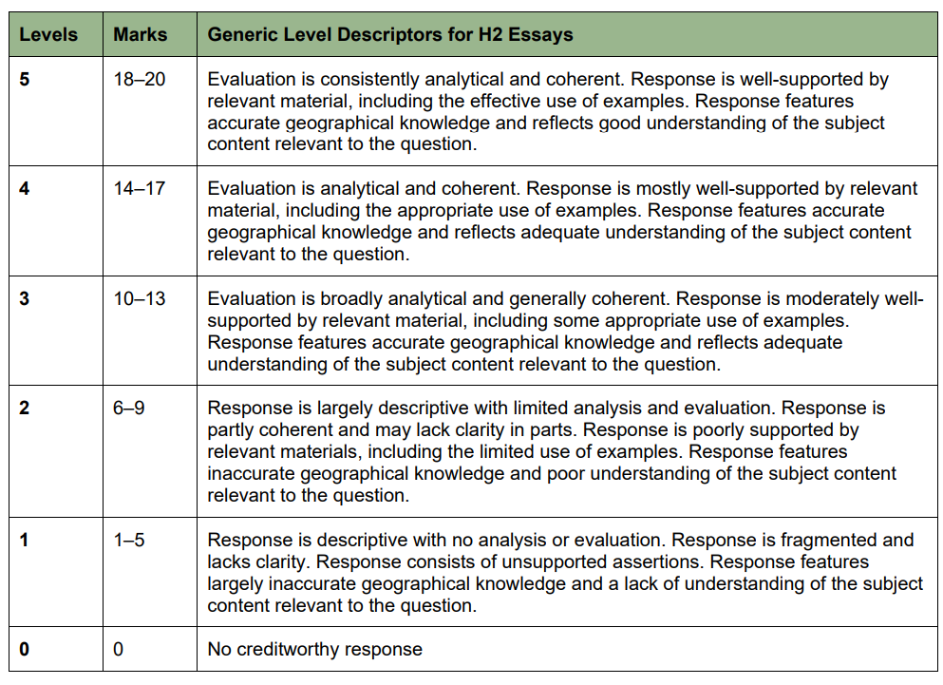 | [20]

